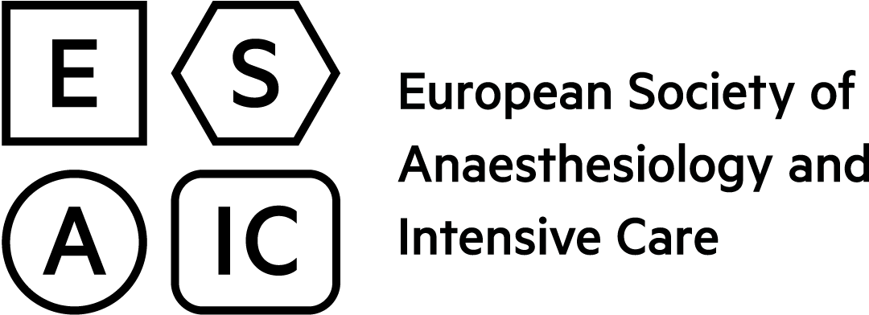 |  |  | European  Board of  Anaesthesiology
Application Form for departments of Anaesthesia
seeking Accreditation as Teaching Hospital by the ESAIC and the EBA
To be completed by the Head of department or the authorised deputy
Please fill in all required fields (in blue) and send to ataic@esaic.org
Use the TAB-key to move forward to the next field – Shift-TAB to move backwards.
The ATAIC is offered on a voluntary basis to the academic departments of anaesthesia which apply for teaching accreditation in accordance with the European Training Requirements.

Name of Hospital
Department
Street + number
Postal code
City
Country
Head of Department details
Surname
First Name
Telephone + country/area code
Telephone + country/area code
E-mail address | @

Website

Type of hospital

N° of beds

N° of trainees

Short description of hospital type and teaching programme

Person to contact (if different)
E-mail address | @

