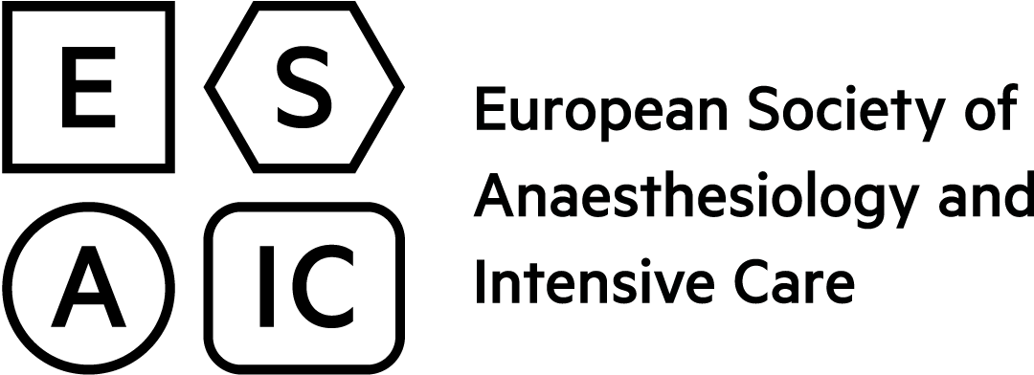 |  |  | European  Board of  Anaesthesiology
Questionnaire for Trainees
Accreditation of Training in Anaesthesiology and Intensive Care
To be completed by the trainees – The ESAIC guarantees strict confidentiality of all returned questionnaires
Please fill in all required fields (in blue) and send to ataic@esaic.org
Use the TAB-key to move forward to the next field – Shift-TAB to move backwards.
1. BASIC DATA

Name of Hospital
Department
City
Country
Name of trainee
Years of clinical training | 1 2 3 4 5 6 7
2. QUESTIONS
Does the training programme have an assigned Programme Director and/or Regional Adviser? |  |  |  | yes no
Do you have a personal tutor/mentor? |  |  |  | yes no
Do you have a written personalised teaching programme? |  |  |  | yes no
Did you have structured induction to both the department and hospital? |  |  |  | yes no
Is there a department library with current literature and Internet access? |  |  |  | yes no
Are there adequate rooms for reading? |  |  |  | yes no
Are there regular staff meetings where trainees attend? |  |  |  | yes no
Is there systematic registration of complications and incidents? |  |  |  | yes no
Are there critical incident conferences where trainees attend? |  |  |  | yes no
Do/did you get involved with research? |  |  |  | yes no
Do you keep a logbook? |  |  |  | yes no
Does the clinical caseload give adequate training opportunity? |  |  |  | yes no
Do you receive sufficient supervision by a specialist in your daily practice? |  |  |  | yes no
Is there a clear faculty commitment and positive attitude to theoretical and practical instruction? |  |  |  | yes no
Is the ratio of fully trained faculty to trainees sufficient? |  |  |  | yes no
Do you receive in-depth exposure to all core competencies? |  |  |  | yes no
Is there training exposure available in all agreed subspecialties? |  |  |  | yes no
Is sufficient time available for personal study and exam preparations (e.g. EDAIC)? |  |  |  | yes no
Is there opportunity/support for attending external educational courses and scientific meetings? |  |  |  | yes no
Does the department provide complete training to become a specialist? |  |  |  | yes no
Do working hours and/or rota planning have impact on training? |  |  |  | yes no
Is supervision available both in and out of hours? |  |  |  | yes no
Does service pressure have effect on training? |  |  |  | yes no

3. OPEN QUESTIONS
How is the progress of your knowledge and skills in the speciality evaluated?
Describe the strengths of the department.
What improvements would you suggest for the department?
What do you expect from a Hospital Visit by the ESAIC/UEMS?
Are there specific areas you think the visitors should look into?
General comments

